THREADCAM INSTRUCTIONS
- Charge the camera using the USB-C charging cable on the side of the thread cam.
- Remove the rubber eye cup on top of the Cylinder Thread Viewer
- The camera will rotate on the top of the lens. You will see a spiral groove in the top lens piece. The bottom of the camera has a matching groove. Lock the camera in place on top of the spiral groove. Around one full turn the camera will be secured to the top of the Cylinder Thread Viewer
- Turn the camera on
- Using WiFi from your phone, tablet or laptop, look for THREADVIEWER in the WiFi signals
  - Connect to the Thread Viewer WiFi
- Once WiFi has connected go to your WEB Browser.
  - Type in 192.168.4.1
  - Or scan the QR Code

Your browser will display the ThreadCam AP
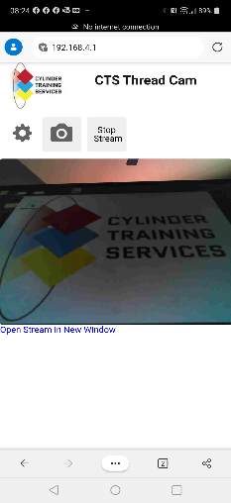
Turn ON the cylinder thread viewer – without lighting from the thread viewer the screen will look blank
- Focus the Cylinder Thread Viewer
  - The image may spin – but you are looking for a clear image
- Once the image is focused – Lock the focus tube with the nylon screw on the side.
- Spin the camera using the knurled knob (might be stiff ) until you achieve a desired orientation
- Holding the index plate – screw the Cylinder Thread Viewer to the bottom of the threads.
CAMERA SETTINGS
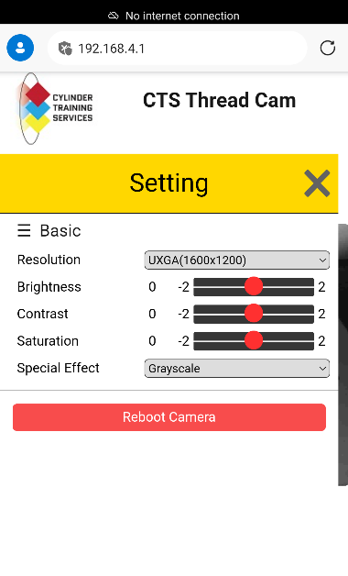
Resolution : Adjust for optimal viewing on your screen size
Brightness: Adjust according the brightness of your screen and the brightness of the LED being used on the Cylinder Thread Viewer
Contrast:
Saturation:
Special Effect:
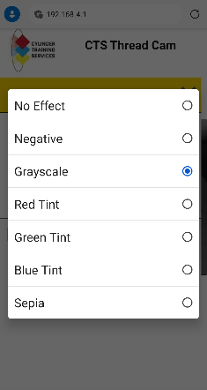
- No Effect – Color
- Negative – reverses dark to light / light to dark
- Grayscale – Black and White (the default setting)
- Tint: red/green/blue – change to personal taste and best viewing on your device
REBOOT CAMERA – resets everything to the default. The user may need to refresh the browser on their device.

Camera use:
- As you rotate the Cylinder Thread Viewer up through the threads the operator can watch the process through the screen.
- If you see something you wish to record in your camera – hit the camera button
  - Your device will store to your default storage location. Or you can choose the location using the download feature
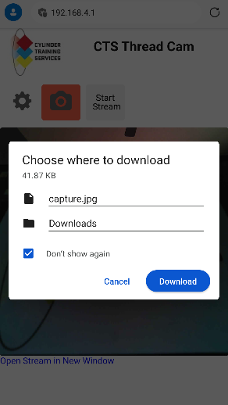
  - Currently there is not a video button. The user will need to use an app from their device to record a video
- If you wish to freeze the image hit – Stop Stream
  - To unfreeze – hit the same button
When finished – turn off the camera and re-charge if necessary. Go back to your device and pair with your preferred WiFi network.

FAQ’s
- The Screen is dark, and does not show anything – turn ON the cylinder thread viewer
- App does not appear
  - Ensure the camera is charged, Turn the unit on, ensure the top indicator light is on
  - Ensure your device is logged into the proper IP: 192.168.4.1
  - Ensure your WiFi is connected to the ThreadCam network
  - Some devices will automatically reconnect with another IP address
  - Refresh your browser
- The video image is blurry – adjust the focus tube on the thread cam
- The image is not straight – While holding the thread tube – turn the camera while holding the knurled knob
Specs:
- Battery
- Camera

